Betty Widget – Google Tag Manager Event Tracking Guide
This guide explains how to track user activity insight the Betty Widget using Google Tag Manager (GTM). No custom development is required beyond standard GTM configuration.

Prerequisites:
- GTM is installed on the site
  - GTM container snippet is installed on the site.
  - If GTM is not installed, nothing below will work
- You have edit access to the correct GTM container
- You know where you want the data to go
  - Most common: Google Analytics 4 (GA4) + what will be used in this guide.

Verify the widget is pushing events (fastest way)
- Open browser DevTools – Console
  - On the page with the widget, right click, select: inspect, top menu, select console

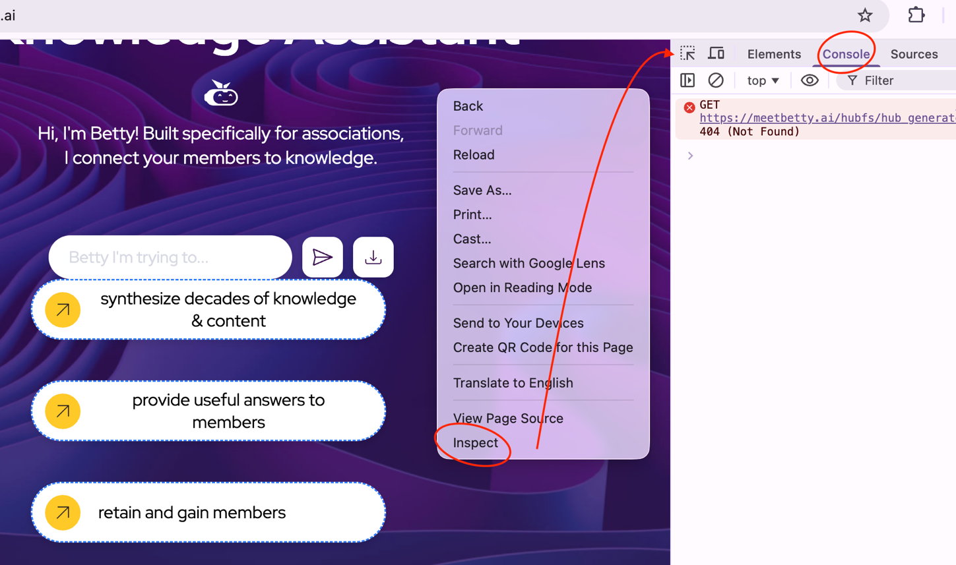

Verify the widget is pushing events (fastest way)
- Run: “window.dataLayer” – In other words, type after the “>” window.dataLayer click enter to run it
- Ask a question in the widget, click a link inside the widget
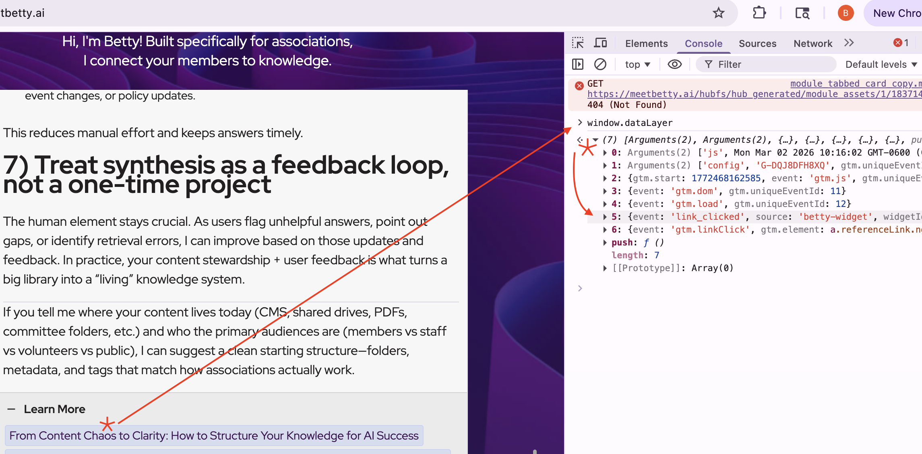
- You should see an object like: event: ‘link_clicked’, source: ‘betty-widget’, etc.
In Google Tag Manager, create Data Layer Variables, so you can use your fields
- Create Variables for each field you send
  - Go to Variables – New – Data Layer Variable (DLV)
- Create these (Recommended), leave Data Layer Version as version 2.
  - DLV – betty_source
    - Data Layer Variable name: source
  - DLV – betty_widgetId
    - Data Layer Variable name: widgetID
  - DLV – betty_href
    - Data Layer Variable name: href
  - DLV – betty_label
    - Data Layer Variable name: label
  - DLV – betty_location
    - Data Layer Variable name: location
In Google Tag Manager, create Data Layer Variables, so you can use your fields

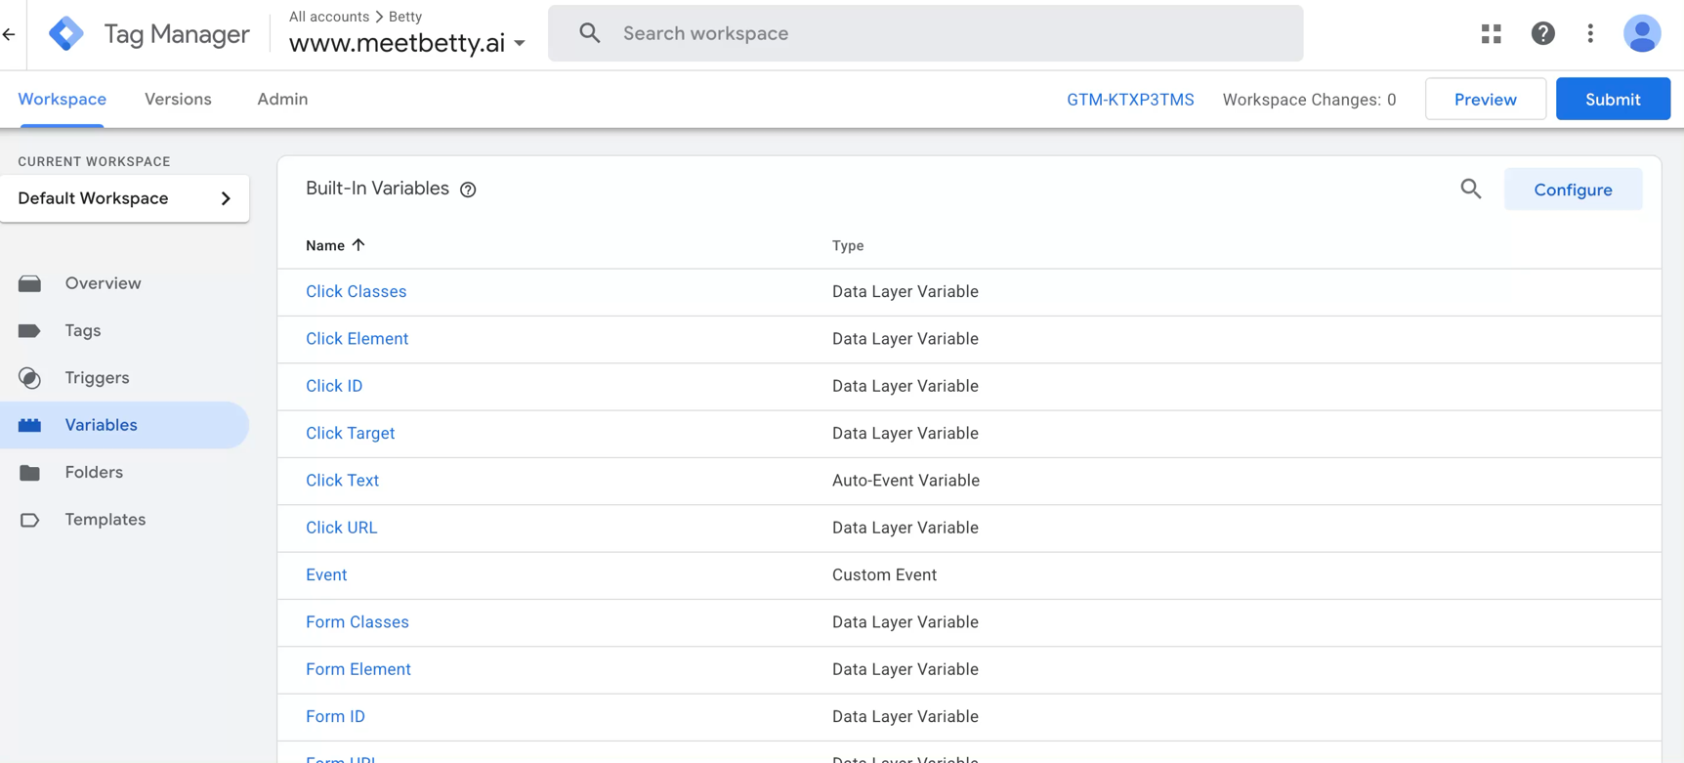
Double click below to see how to add Data Layer Variables:

Create the Trigger that listens to your event, in Google Tag Manager
- Go to Triggers – New
  - Trigger type: choose Custom Event
  - Event name: link_clicked
  - Add filters (highly recommended)
    - Set DLV – betty_source equals betty-widget, betty_widgetId equals your-widget-id
      - Your widget ID should be your instance name, found in INSIGHTS portal
  - Save as CE- Betty link_clicked

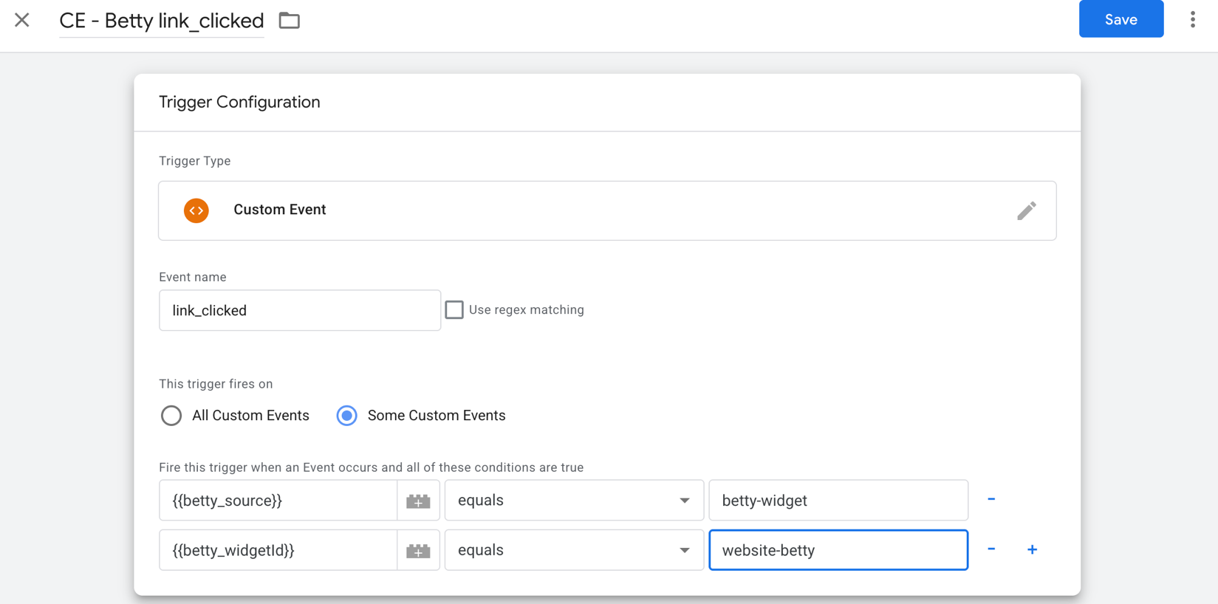

Send to GA4
If you have Google Tag (or GA4 configuration), proceed to step B.
Step A: Connect GTM to GA4
- GTM – Tags – New
- Tag type: Google tag (or GA4 configuration), Mesurement ID: G-XXXXXXX, Trigger: All Pagers, Save.

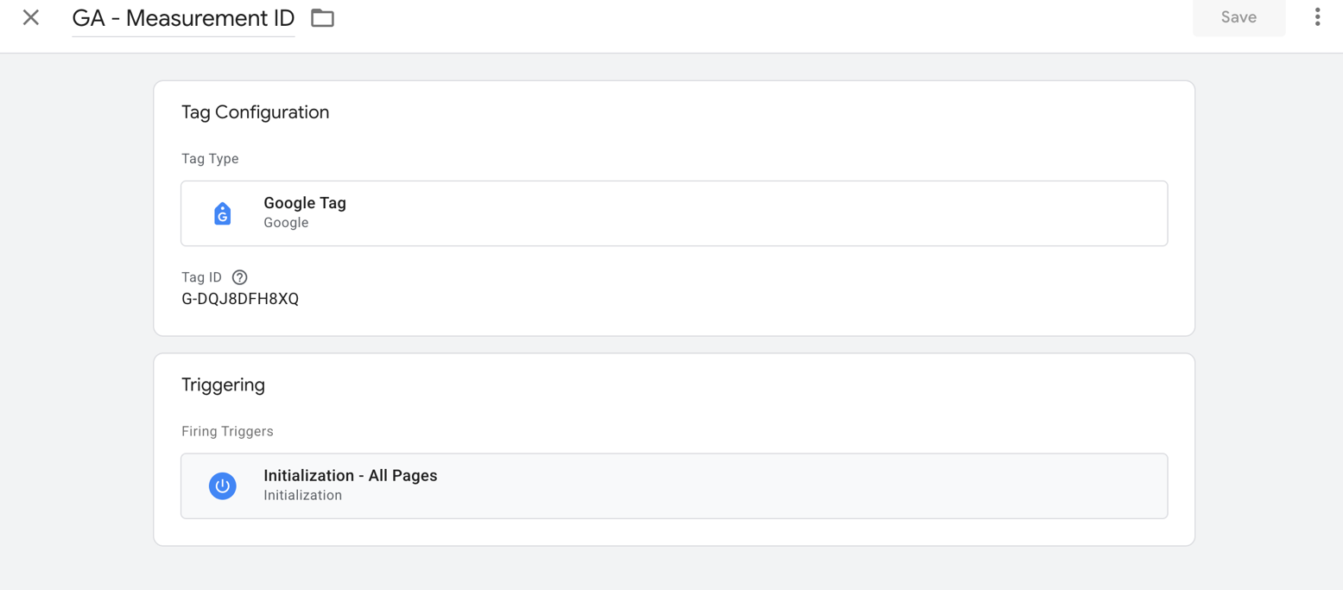
Send to GA4
Step B: Create the GA4 Event Tag
- GTM – Tags – New – Google Analytics: GA4 Event
- Configuration tag: select your Google tag / GA4 configuration
- Event name: betty_link_clicked
- Event parameters (recommended):
  - widget_id = {{DLV - betty_widgetId}}
  - link_url = {{DLV - betty_href}}
  - link_text = {{DLV - betty_label}}
  - link_location = {{DLV - betty_location}}
  - betty_source = {{DLV - betty_source}}
- Trigger: CE - Betty link_clicked
- Save as: GA4 - betty_link_clicked

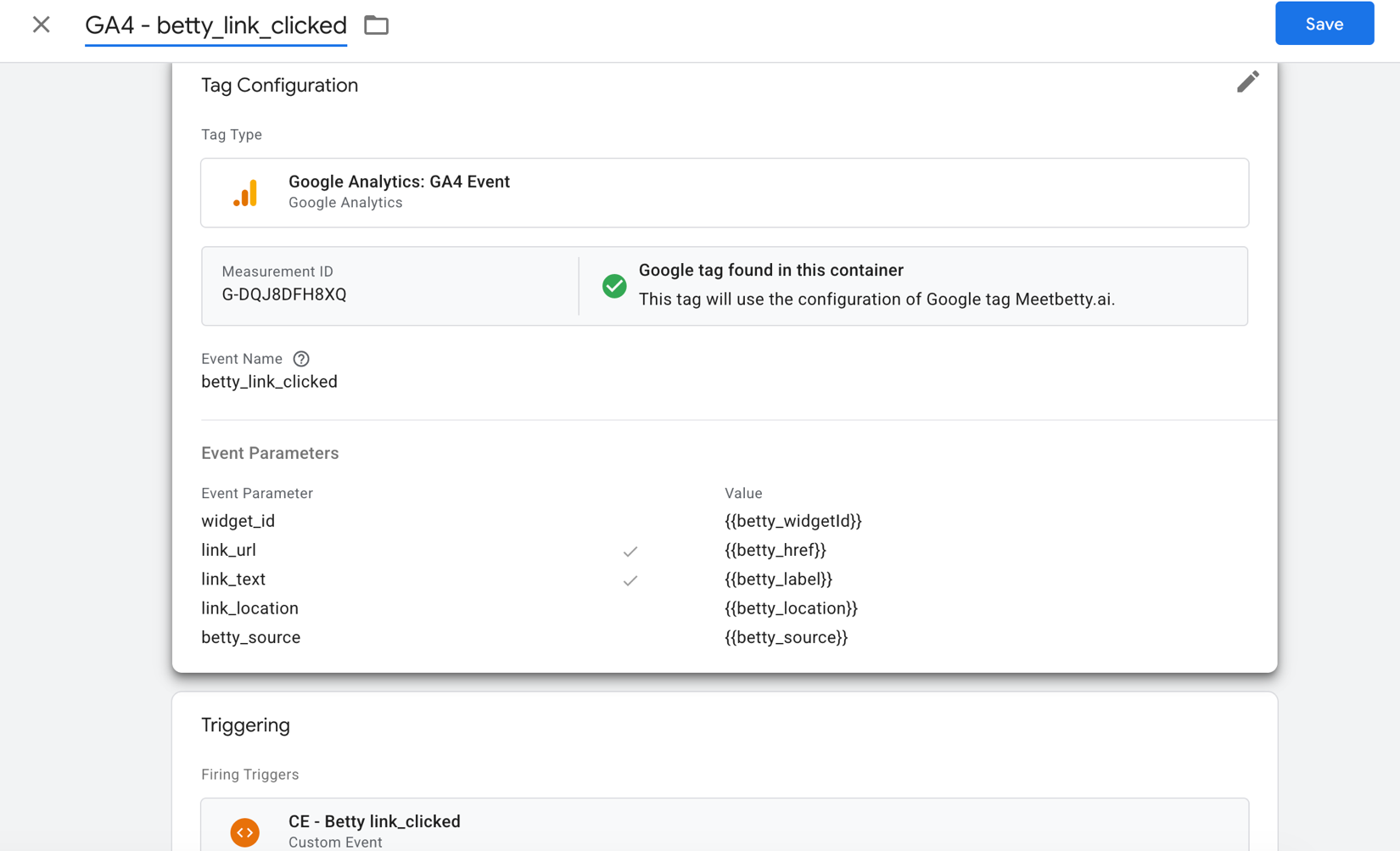

Test before Publishing
A) GTM Preview mode
- GTM → Preview
- Enter site URL → connect Tag Assistant
- Engage with the widget and click a Betty-generated link
You should see:
- Event appears: link_clicked
- Trigger fires: CE - Betty link_clicked
- Tag fires: GA4 - betty_link_clicked

B) Confirm DLVs populate (do this every time)
In Preview:
- Click the link_clicked event
- Go to Variables
- Confirm these have values:
  - betty_source
  - betty_widgetId
  - betty_href
  - betty_label
  - betty_location
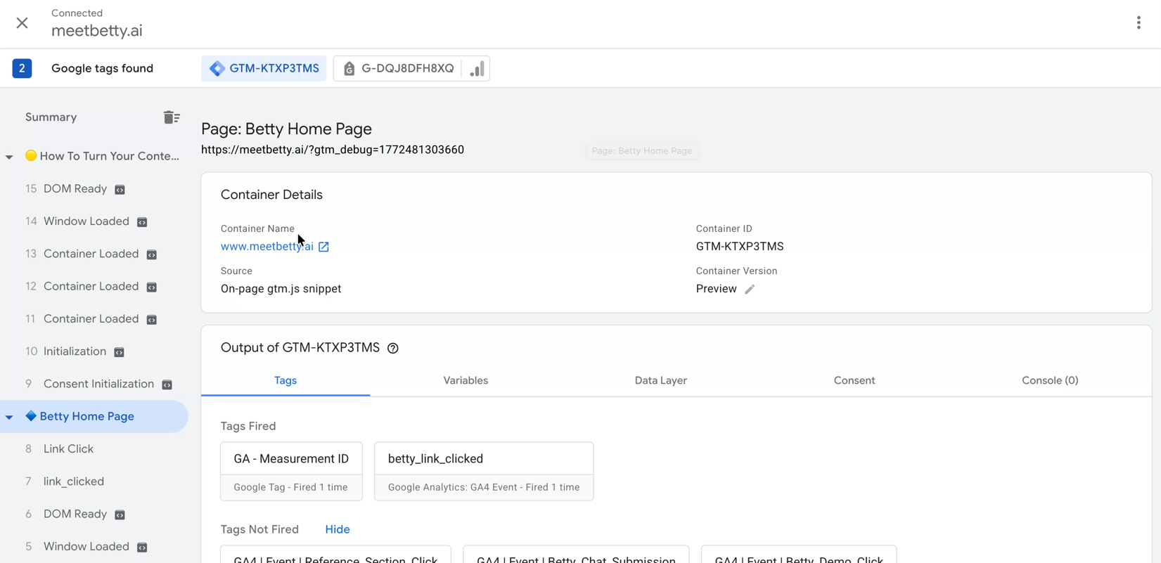
- Double click below to see what it should look like after preview:
Publish
GTM – Submit – version name – Publish

Make it usable for GA4 reporting (optional but recommended)
In Google Analytics 4
- Go to Admin (gear on the bottom left), click on custom definitions under data display in left side navigation menu
- Create Event-scoped dimensions for:
  - widget_id
  - link_url
  - link_text
  - link_location
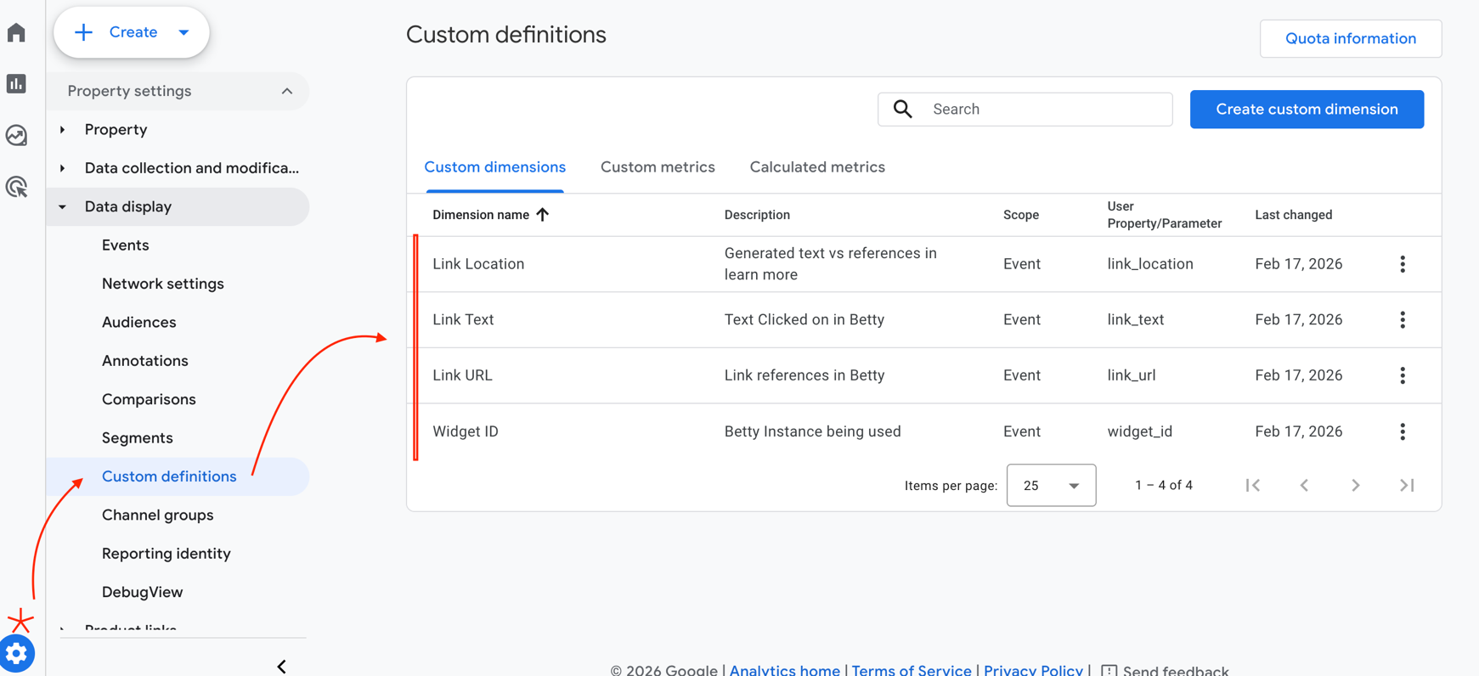
Important: these won’t backfill. They’ll apply going forward.

Reporting: “Most clicked links in Betty”
Best method: Explorations (Free Form Table)
- GA4 → Explore → Free form report
- Update Dimensions to include: Event name, Link URL, Link Text, Widget ID, Link Location
- Update Metrics to include: Event Count
- Set up Rows to include: Link URL, Link Text, and Link Location
- Set up Columns to include: Widget ID
- Set up Values to include: Event Count
- Set up Filters: Event name exactly matches: betty_link_clicked

Note: Some GA4 properties do not allow “today” in Explorations. Additionally, custom definitions do not back track. So, this report will start giving today from today forward.

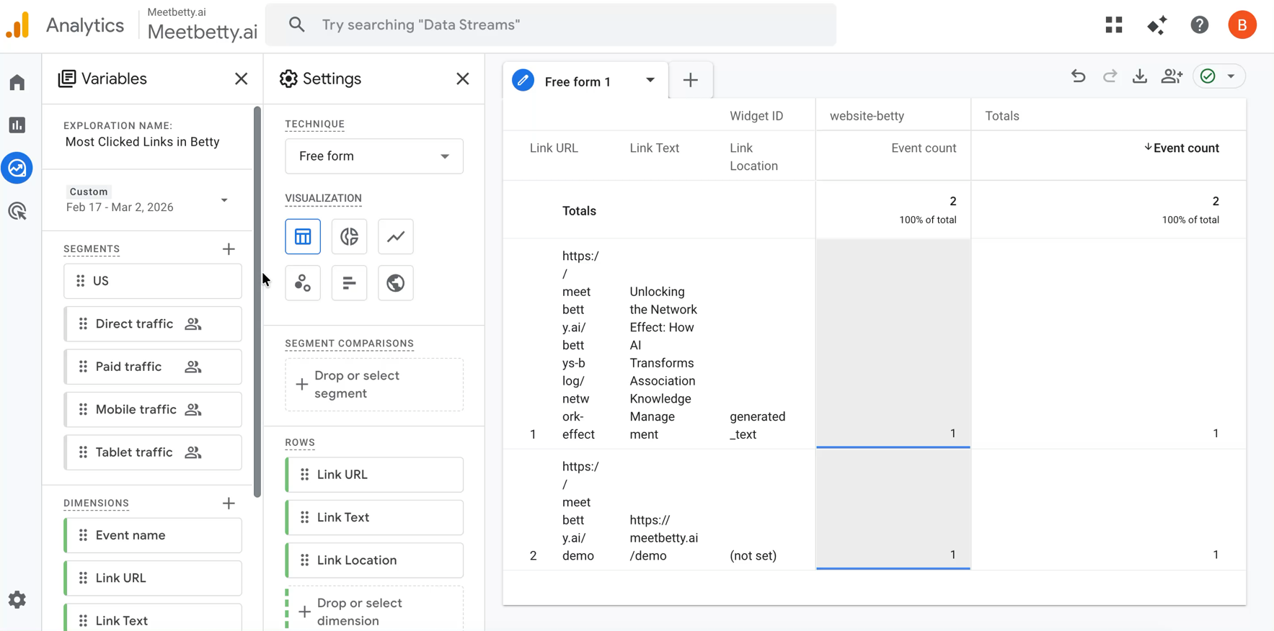
Double click below to see the full set up:

